**1. Open a Terminal from the Activities Button**

**type ls /root**

**What is the error message?**

**What command can be added in order to give us the correct permissions?**

**Add this command and take a screenshot of the output**

**A**: The error message is “bash: ls/root: No such file or directory” and we should add “sudo”.

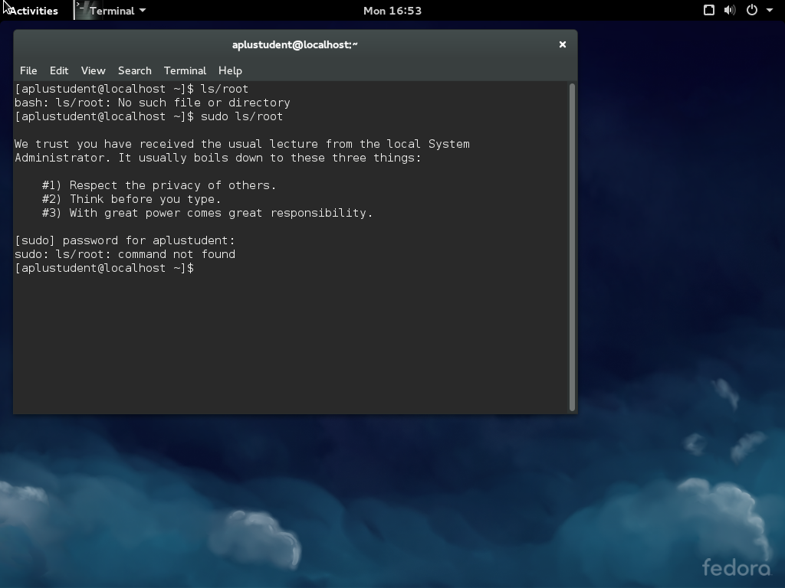

**2. Launch Firefox from the Activites button**

**then click activities**

**select a second virtual desktop**

**Launch a terminal on the virtual desktop**

**Click the Activities button and hover over the virtual desktops and take a screenshot**

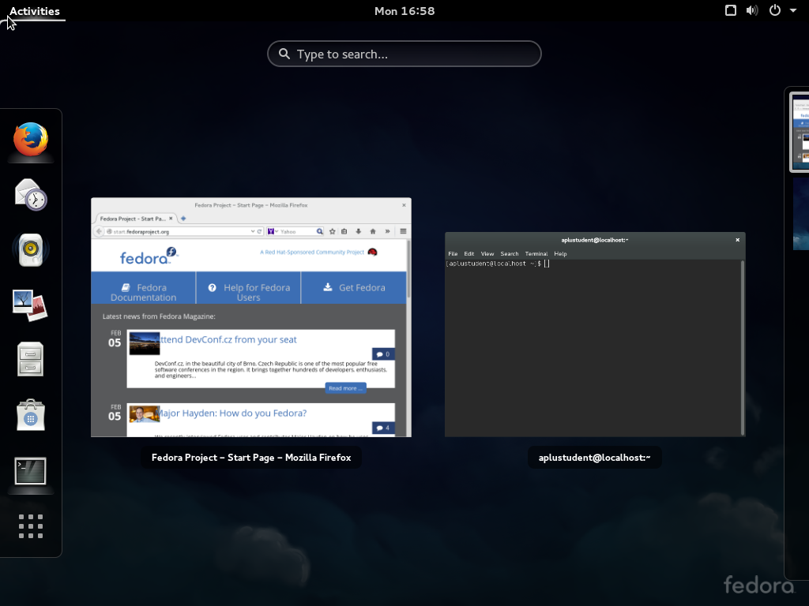

**3. Launch Libre Office Writer from the Activities menu**

**Click on the white triangle on the Title Bar (near the name of the application) select "About"**

**Submit a screenshot**

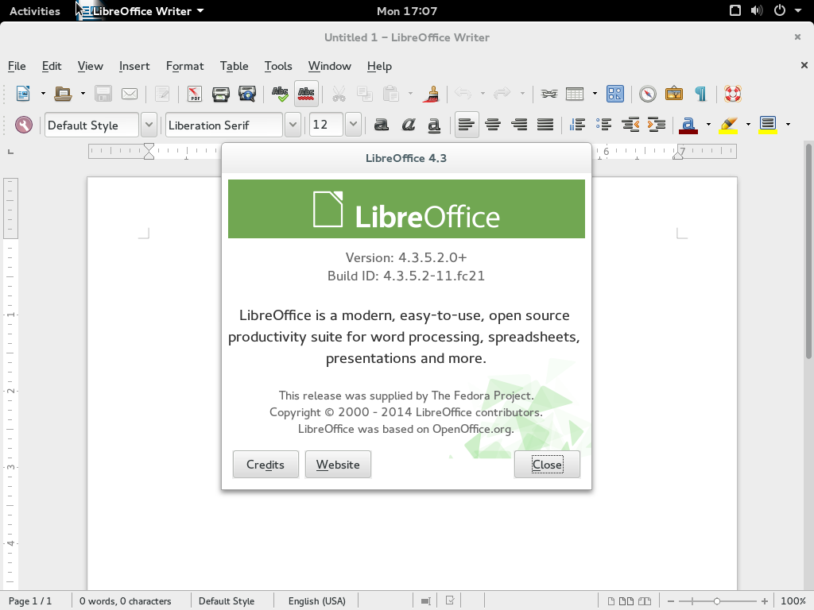

**4. Visit http://vivaldi.com download the rpm for Fedora Linux to downloads**

**Open Nautilus File Manager**

**Select Downloads**

**Take screenshot of downloads directory**

**Install the Vivaldi RPM**

**Launch Vivaldi from Activities and take a screeshot of the Vivaldi web browser**

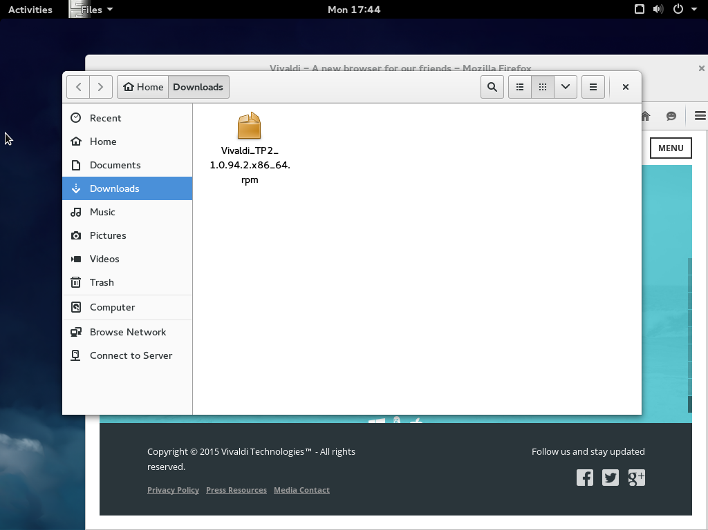

**5. Launch Settings from Activities**

**Open Users Tab and add a new user account with your name**

**Take a screenshot**

**Open the Background Tab**

**Select a new background**

**Take a screenshot of the new desktop background**

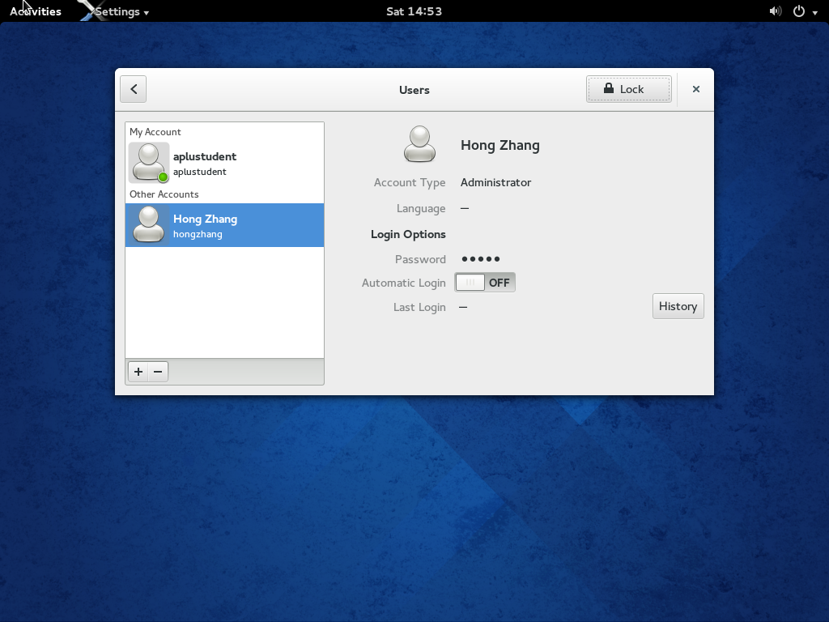

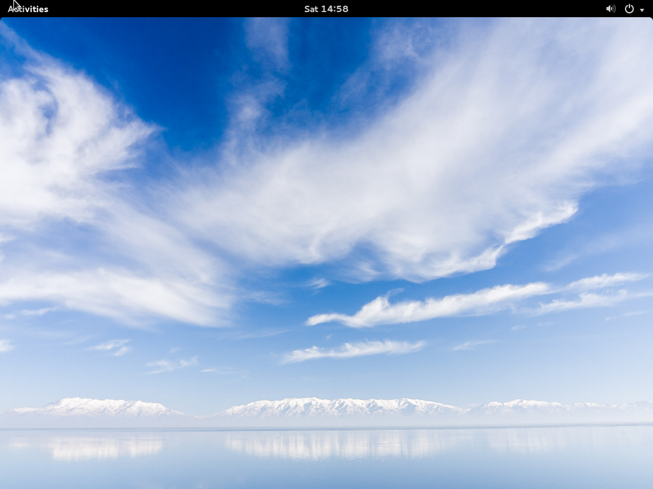

**6. Launch Software from Activities**

**Click on the Development Software Tab**

**Select Eclipse IDE for install**

**Launch Eclipse after install and take a screenshot**

**On the ALL tab select Office and install GNUMERIC**

**Take a screenshot of the INSTALLED TAB showing that GNUMERIC is present**

**Uninstall GNUMERIC and take a screenshot showing GNUMERIC uninstalling**

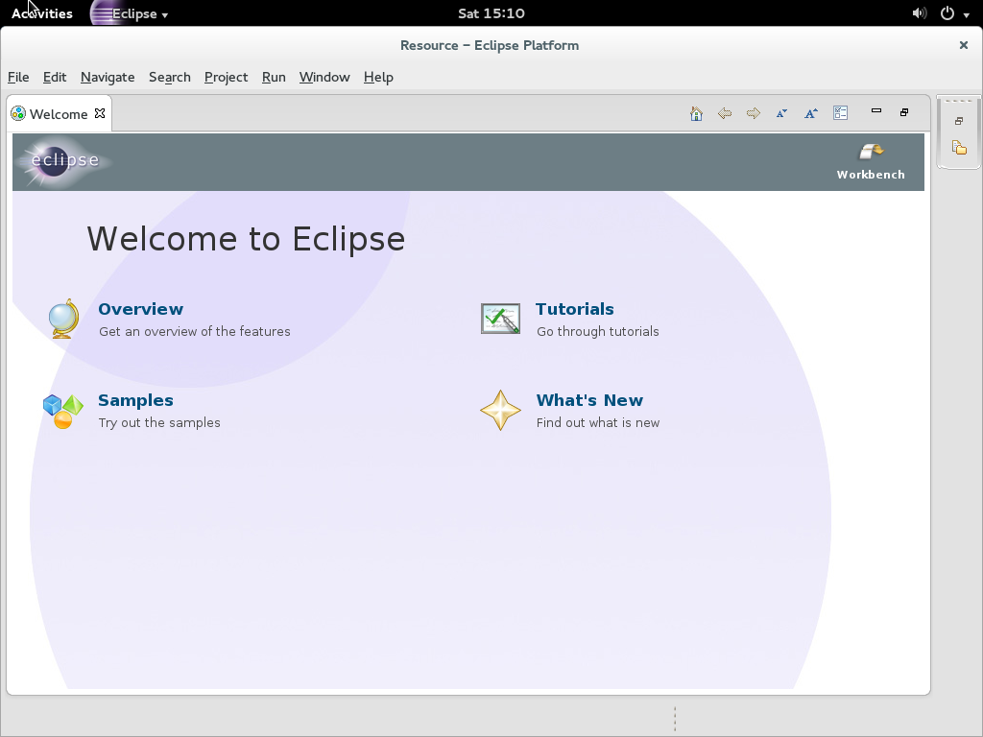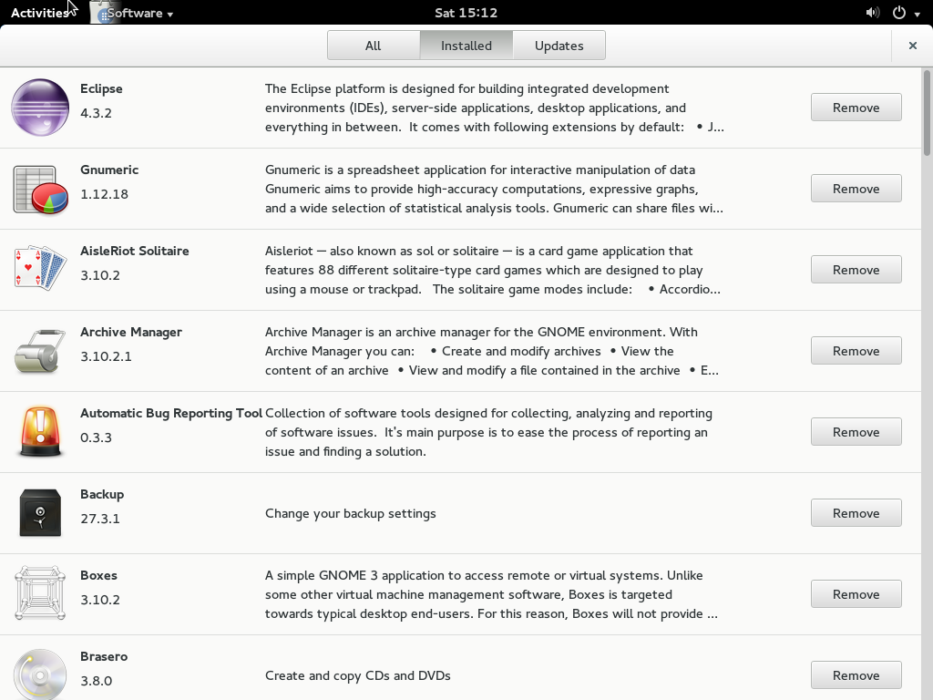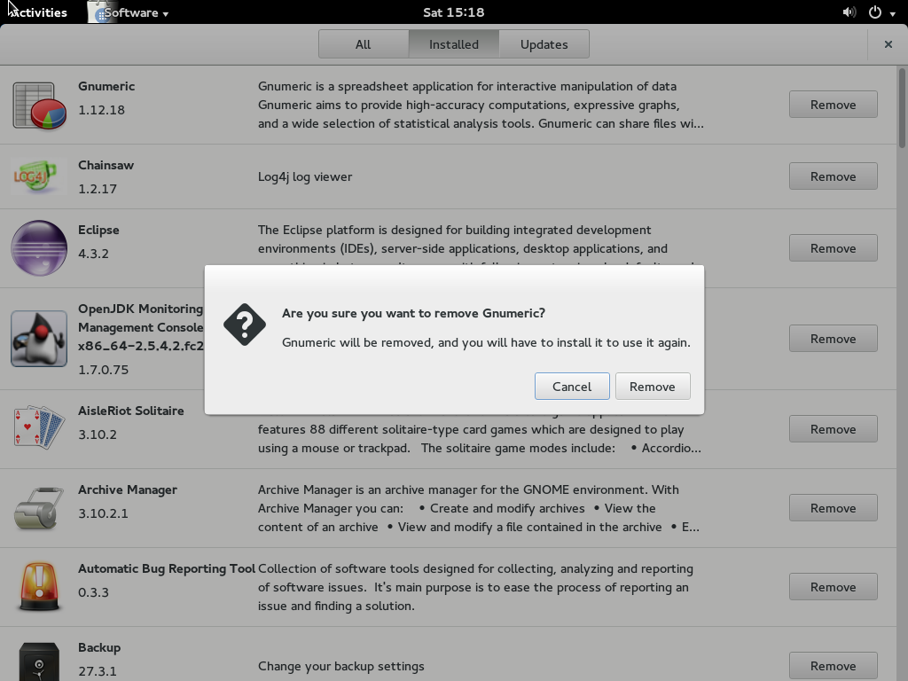

**7. Open a TERMINAL from Activities**

**type yum update - what happens? Why?**

**What command is needed to give yum enough install permissions?**

**Type sudo yum group install lxde-desktop**

**Upon completion in the upper right hand corner (white arrow) select log output**

**You will be presented with the GDM again (login but this time before you type your password - there will be a little gear icon next to your password box. Click it and change your desktop from GNOME to LXDE**

**Log in and take a screenshot of LXDE desktop**

**Don't forget to logout and change back to GNOME 3 if you want**

**A:** When I type “yum update”, I get an error message, “You need to be root to perform this command” because root privileges are needed for some operations. Sudo will give yum enough install permissions.

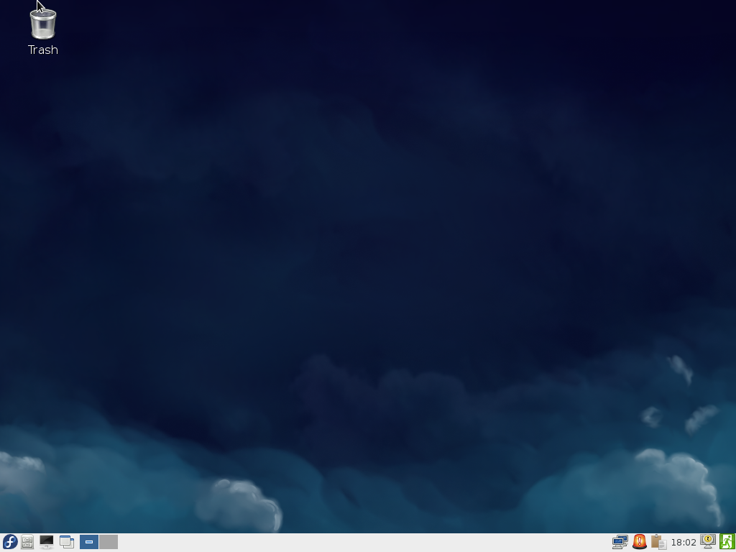

**8. Shell commands short answer:**

**Which command option for ls will show Long Listing?**

A: -l is the option which will give you a long listing format

**Which command option for cp will show verbosely what is being copied?**

A: -v — verbose shows the progress of the files being copied.

**Which command for rm will ask for interactive permission before completing the operations?**

**A:** -I (-i) –interactive prompt before any removal

**9. Shell commands short answer:**

**What does the command ls -Fcla show?**

A: The ls command is used to list the contents of a directory and –Fcla is many options which include –F, –c (–etc), –l and –a.

–F (file type) adds a symbol to the end of each listing. These symbols include /, to indicate a directory; @, to indicate a symbolic link to another file; and *, to indicate an executable file.

–c(etc) Lists the files in the /etc directory in long format.

–l (long) lists details about contents, including permissions (modes), owner, group, size, creation date, whether the file is a link to somewhere else on the system and where its link points.

–a (all/archive) lists all files in the directory, including hidden files (.filename).

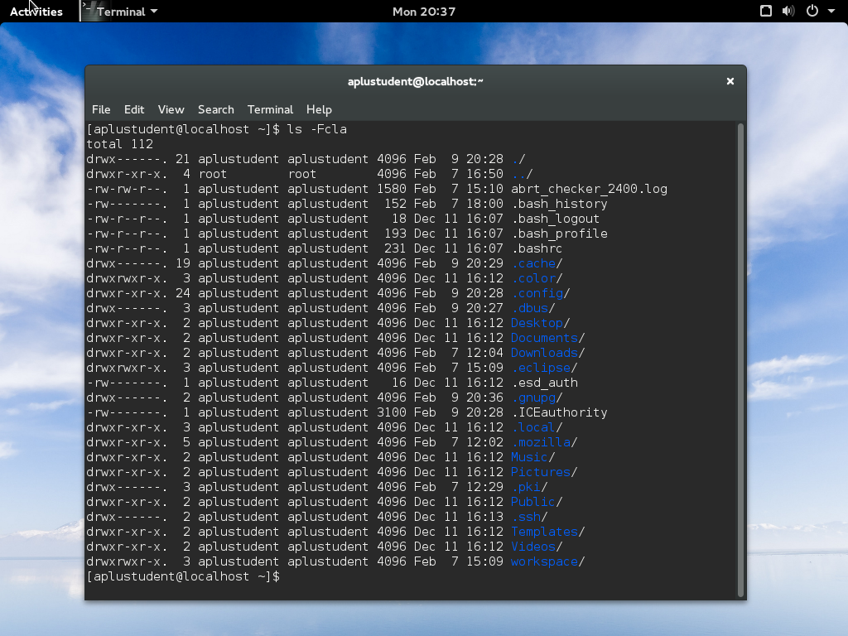

**Which command displays the content of a text file?**

A: cat

**How do you rename a file on the commandline?**

A: mv

**10. You are asked to run the top command but are not sure on its usage and purpose - what would be an acceptable command to find out? (No google is not the right answer)**

**(also give a short explanation of what the top command does)**

A: Manual command or man pages can help us to find all options and features of a shell command. Type “man cp” in the terminal and we can find a short explanation for the top command: it provides a dynamic real-time view of a running system. It can display system summary information, as well as a list of processes or threads currently being managed by the kernel. The types of system summary information shown and the types, order and size of information displayed for tasks are all user-configurable.